**Cultural Facilities**

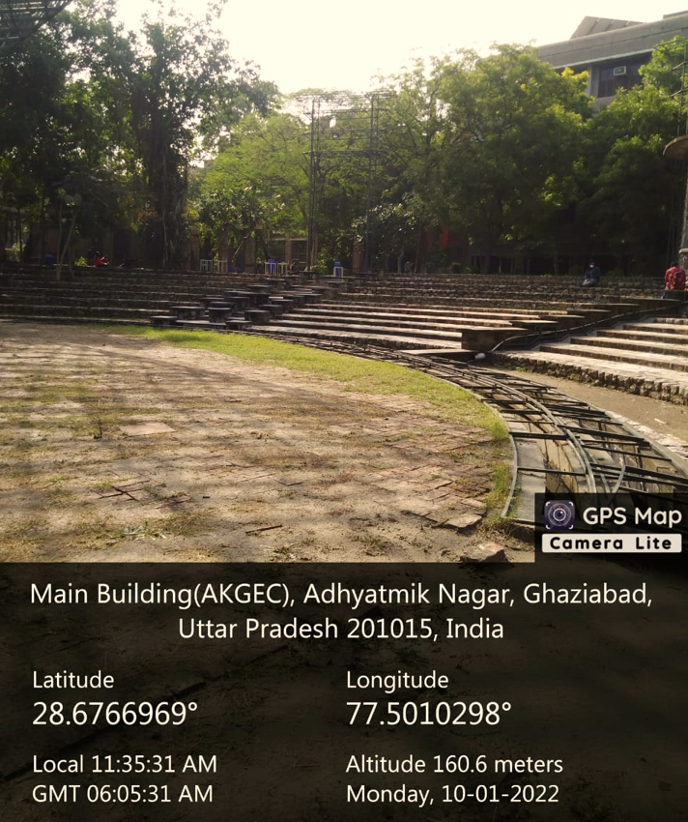

(Amphitheatre, Administrative Block)

(Amphitheatre, Administrative Block)

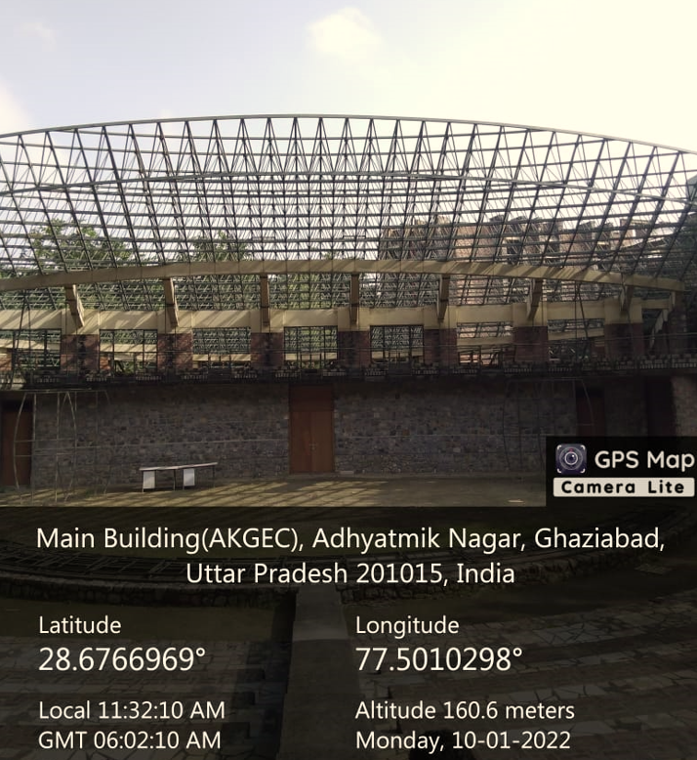

(Amphitheatre, Administrative Block)

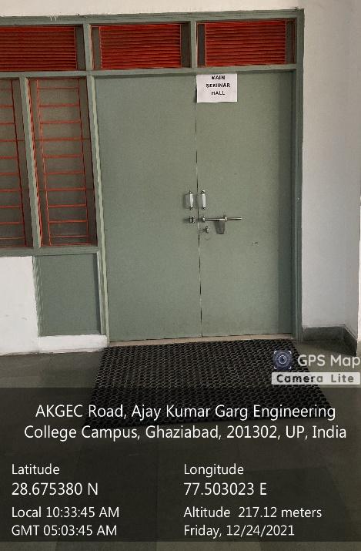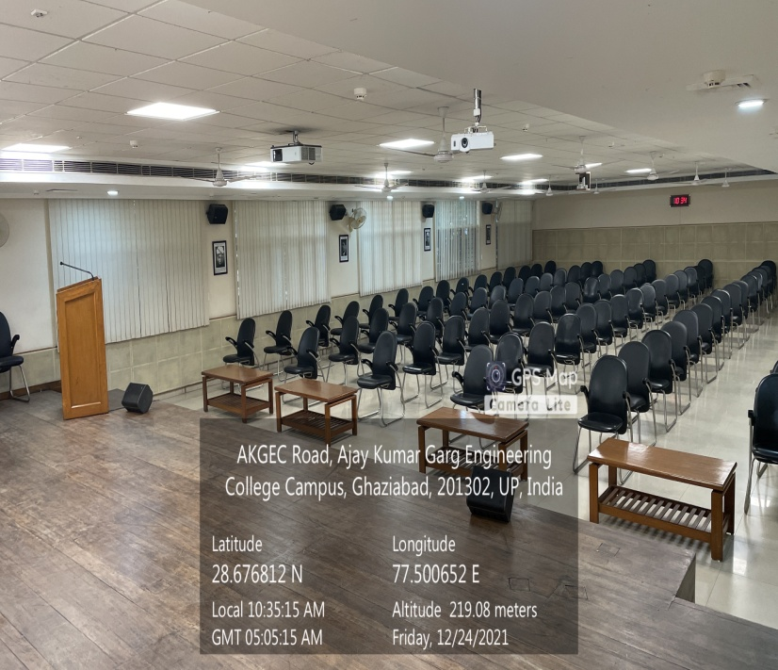

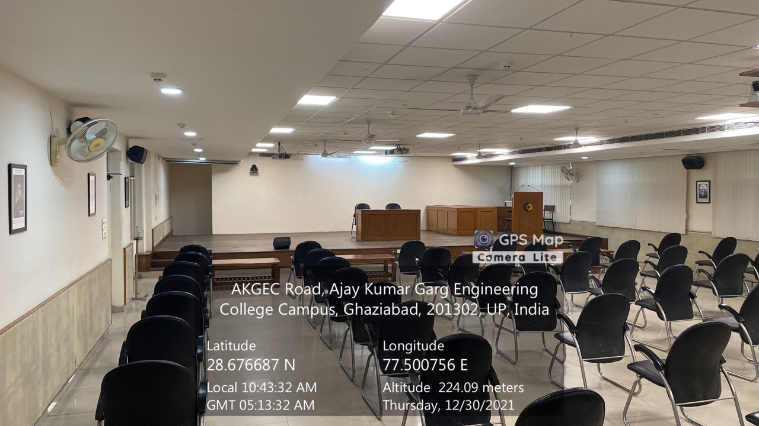

Main Seminar Hall

(ADMINISTRATIVE BLOCK, Second Floor)

Facilities: (Projector, Sound System, Wi-Fi, LAN, Dressing room)